What Are Mythical Creatures?
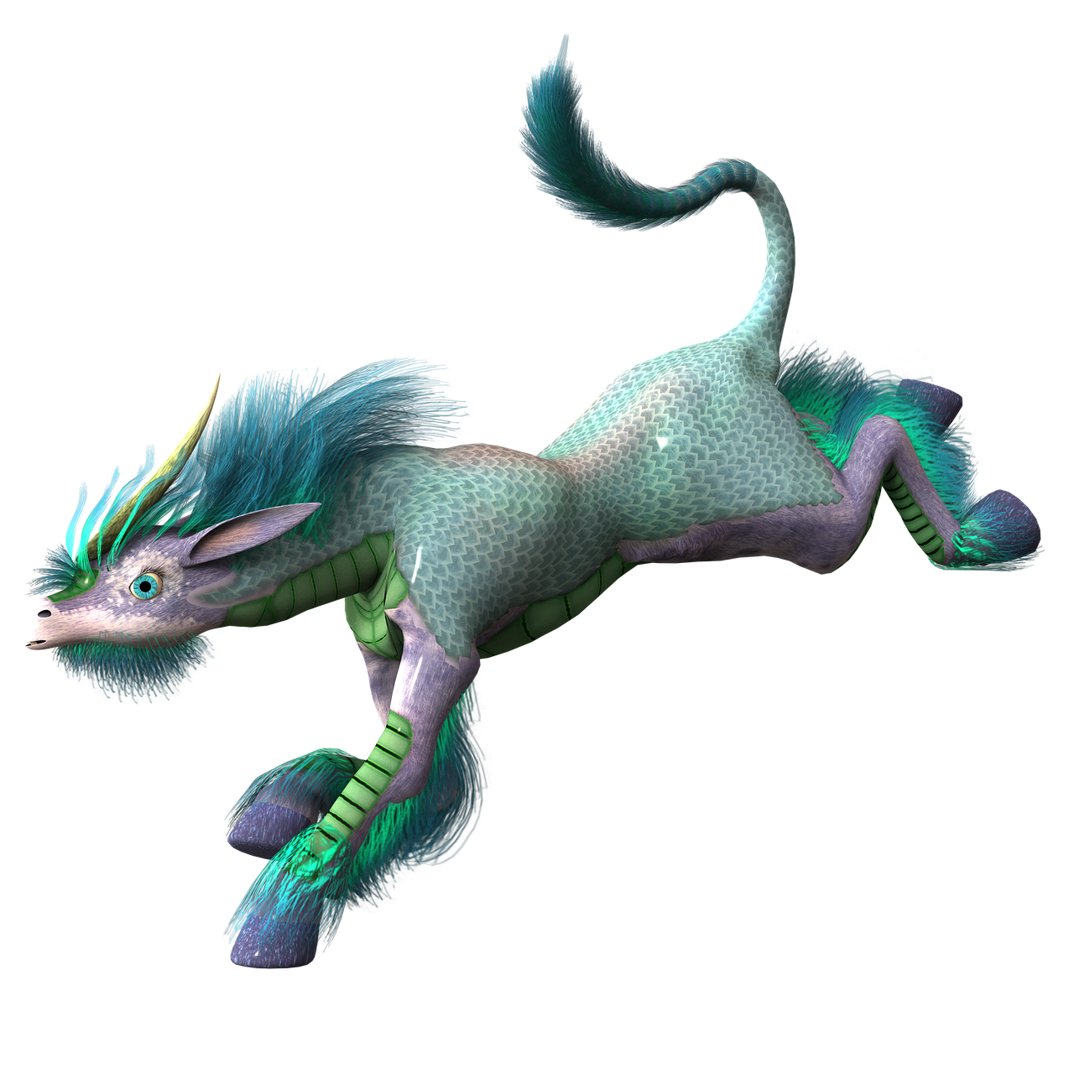
Mythical creatures are almost always literary creatures that generated popularity out of literary circulation and story-telling. They are legendary creatures that at one point were believed to be real beings, while some have their origin traced from literary myths.
Mythical creatures can be found from ancient times to modern days. They range from stories to news broadcasts. Some people believe in them, while others do not. Discussions range on them and arguments ensue. The reason; people are fascinated. It seems forbidden, magical, lost and unknown. It drives people to have passion, some a reason to live and others a reason to write. How does it drive you?

